Geometry: Unit 8, Lesson 2
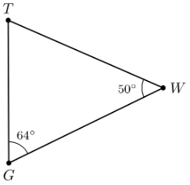
- $∆GWT$ where $m∠TGW=64°$ and $m∠GWT=50°$ is shown. What is the measure of $∠GTW$?

$$66°$$

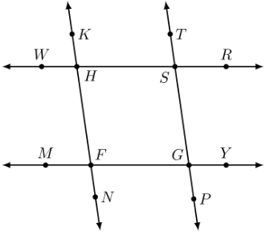

- Lines $KN$, $TP$, $RW$, and $YM$ where $\overset{⃡}{RW}∥\overset{⃡}{YM}$ and $\overset{⃡}{KN}∥\overset{⃡}{TP}$ are shown. $m∠FHS=\left(7x+14\right)°$, $m∠GSH=\left(3x+6\right)°$, and $m∠FGS=\left(9x-18\right)°$. What is an equation that can be used to find the value of $x$?

$$7x+14=9x-18$$

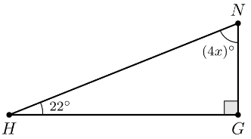
- Right Triangle $HNG$ where $m∠NHG=22°$, $m∠NGH=90°$, and $m∠GNH=\left(4x\right)°$ is shown. What is the value of $x$?

$$17$$

